Create a database called “Sales” and create a new table named “Orders” in the Sales database with columns: (Order_Id, Customer_name, Product_Category, Ordered_item, Contact_No). Use constraints: Primary Key Unique Not Null.

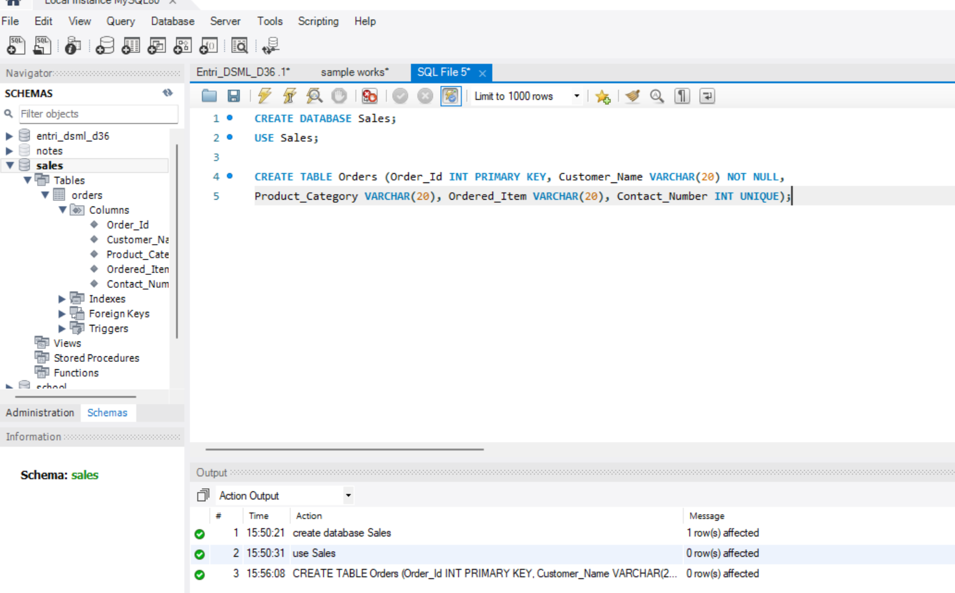  
1. Add a new column named “order_quantity” to the orders table.

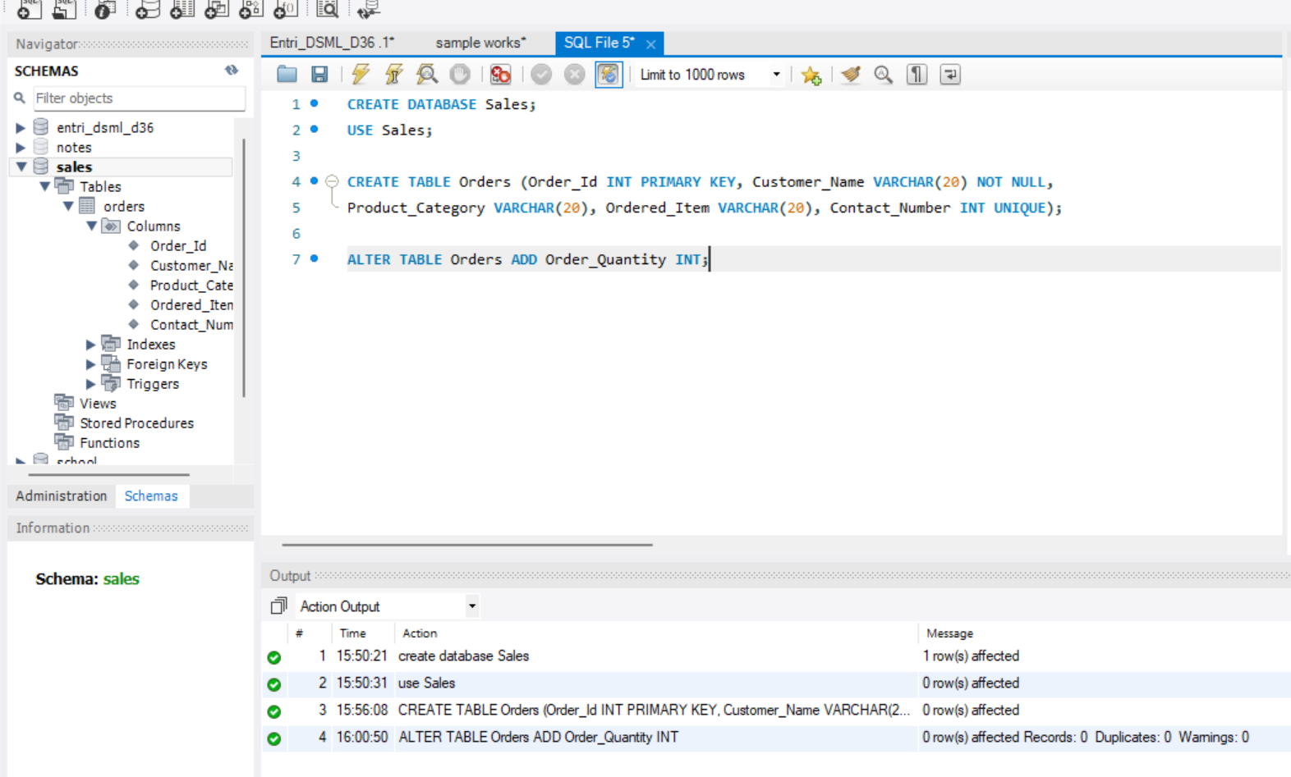

2. Rename the orders table to the sales_orders table.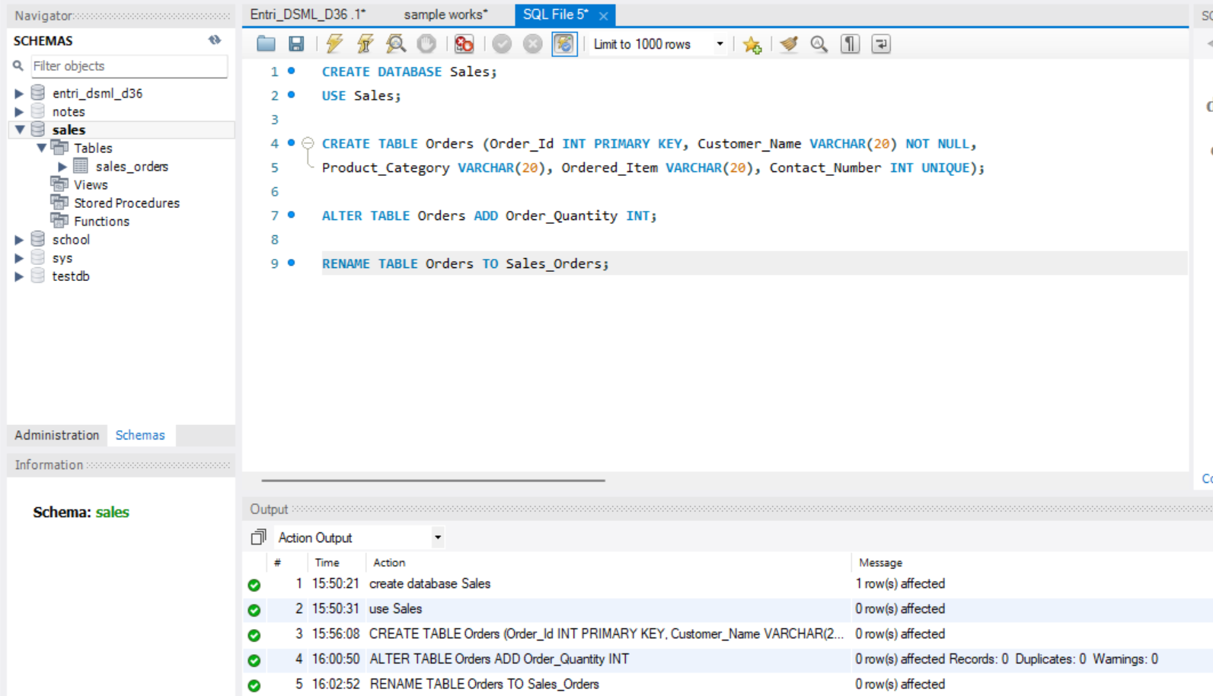

3. Insert 10 rows into the sales_orders table.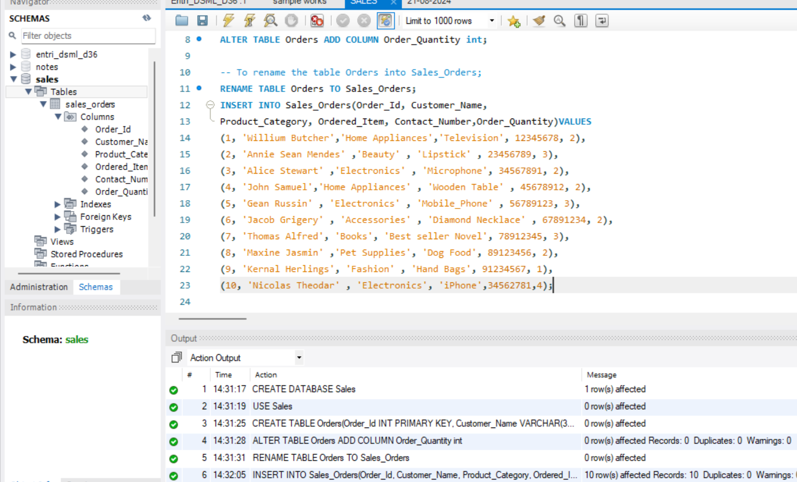

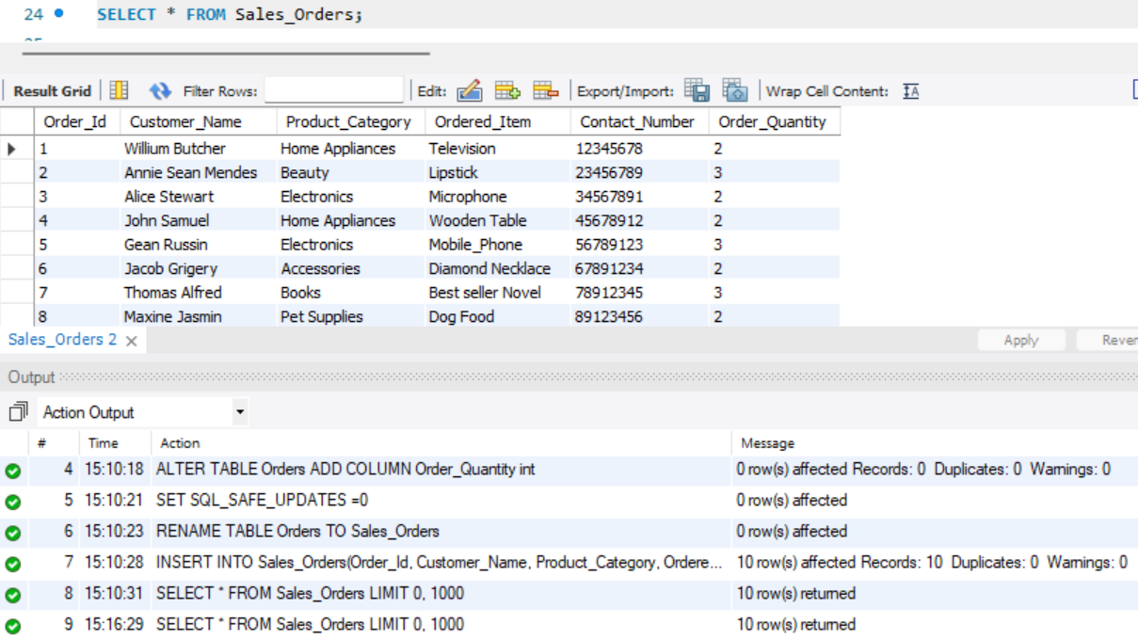

4. Retrieve customer_name and Ordered_Item from the sales_orders table.

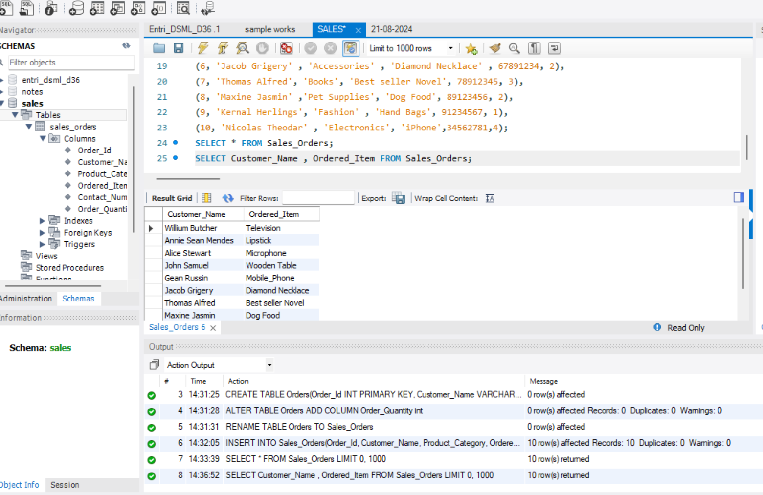

5. Use the update command to change the name of the product for any row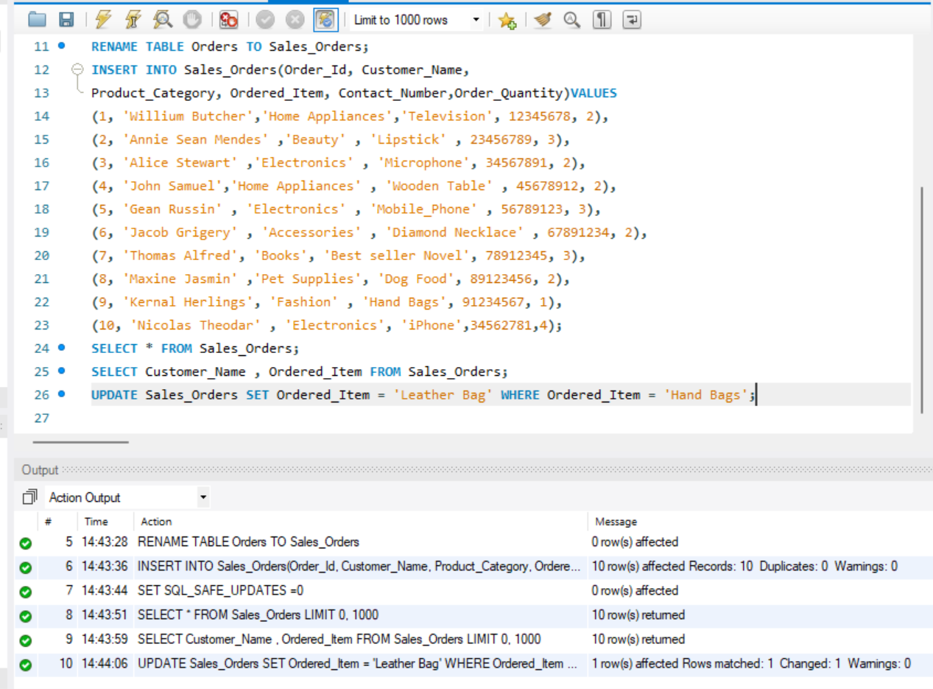

6. Delete the sales_orders table from the database.